DAILY ASSESSMENT FORMAT
Date: | 01 JUNE 2020 | Name: | SanthoshReddy
Course: | NETWORK THEORY | USN: | 4AL18EC046
Topic: | 1.ANALYSIS OF CLOCKED SEQUENTIAL CIRCUITS WITH D FLIP-FLOPS  2.DIGITAL CLOCK DESIGN | Semester & Section: | IV SEM & A SECTION
Github Repository: | Santhoshreddy

FORENOON SESSION DETAILS
Image of session
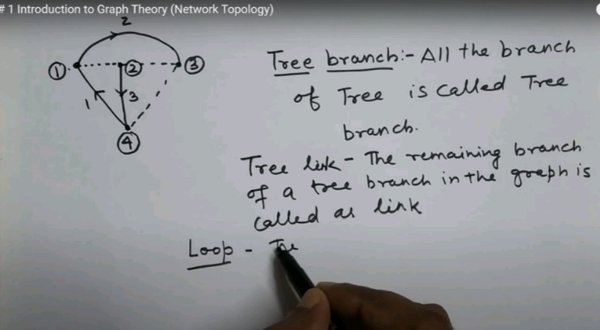
Report – Report can be typed or hand written for up to two pages.
NETWORK TERMINOLOGY
BASIC CIRCUITS ANALYSIS AND NETWORK TOPOLOGY
GRAPH OF A NETWORK
TREE OF A GRAPH AND INCIDENCE MATRIX
FORMATION OF TIE-SET AND CUT-SET MATRIX AND ITS APPLICATION IN KVL AND KCL

AFTERNOON SESSION DETAILS
Date:01 JUNE 2020 |  | Name: Santhoshreddy
Course: PYTHON |  | USN: 4AL18EC046
Topic: APPLICATION:-SCRAPE REAL ESTATE PROPERTY DATA FROM THE WEB |  | Semester & Section: IV SEM & A SECTION

Image of the session
Report – Report can be typed or hand written for up to two pages
SCRAPED WEBSITE DATA – HOW THE OUTPUT WILL LOOK LIKE
REQUEST HEADERS
LOADING THE WEBPAGE IN PYTHON
EXTRACTING “DIV” TAGS
EXTRACTING ADDRESSES AND PROPERTY DETAILS
EXTRACTING ELEMENTS WITHOUT UNIQUE IDENTIFIERS
SAVING THE EXTRACTED DATA IN CSV FILES
CRAWLING THROUGH WEBPAGES

